Tabari Harvey Module 8.2 Assignment

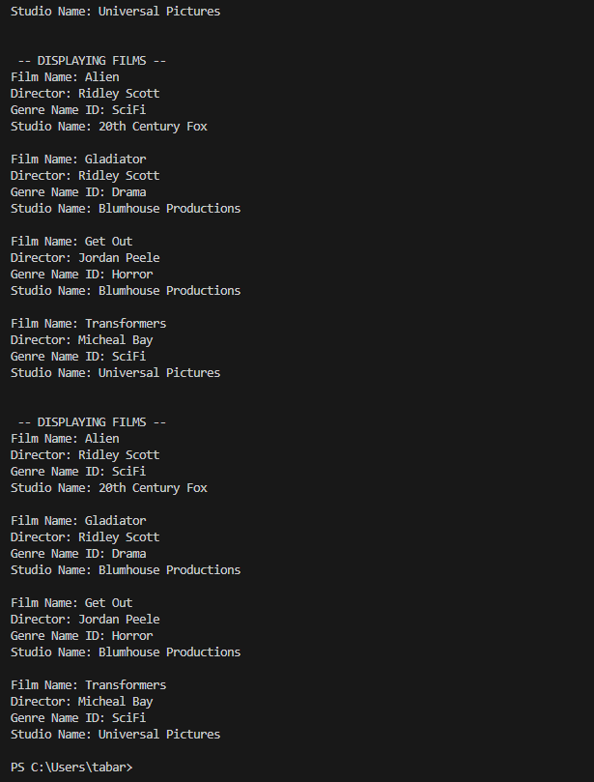

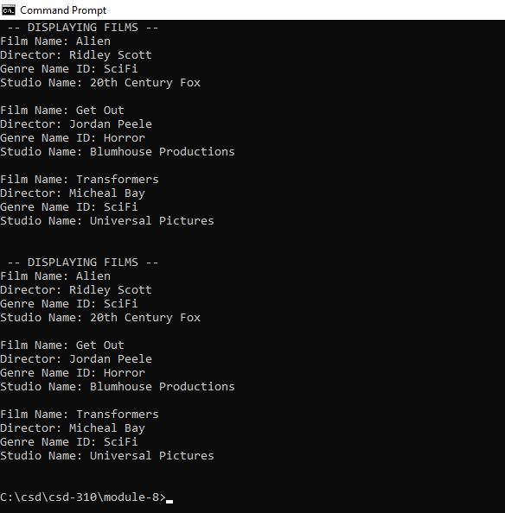

<https://github.com/MurphT4stic?tab=repositories>